International Conference on Radiation Medicine    Clinical Applications and Innovative Approaches  King Faisal Specialist Hospital and Research Centre  Riyadh, Kingdom of Saudi Arabia  27 February – 01 March 2012 / 05 – 08 Rabia Al-Thani 1433 | ABSTRACT FORM  Abstracts will be reviewed by the Scientific Committee and selected on the basis of originality, validity, significance and relevance to the conference. | Office Use  No.
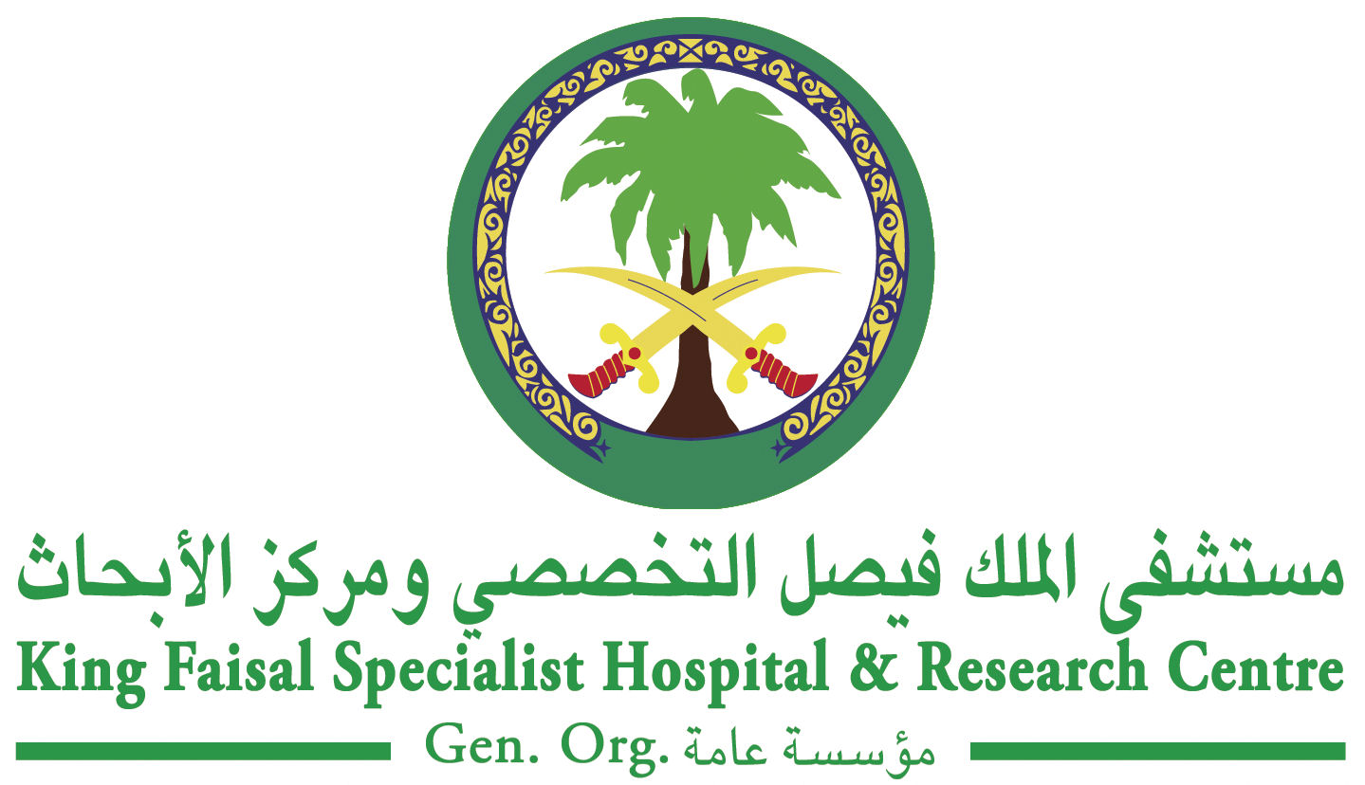
Title:  Author(s): | Deadline for submission  extended until  31 December 2011  6 Safar 1433

Abstract (maximum 250 words):

Topics Selection: |  |  |  | Disclosure:  Has this work been previously presented?  Yes No No  If yes, where and under what circumstances was the abstract presented. Please attach details.
Radiation Oncology  Advanced Beam  Delivery  Brachytherapy  Dosimetry  IORT  IMRT  Treatment Planning  Dose Calculation  Algorithm/Monte Carlo  IGRT/Adaptive  Radiotherapy  SRS/SRT  Immobilization  & Positioning  Other Topics (specify):  Diagnostic Imaging | Cardiovascular Imaging  CT  MRI  Nuclear Medicine  Particle Therapy  SPECT/CT  PET/CT  Interventional Radiology  Radiopharmaceuticals  X-ray Imaging/  Mammography  Molecular &  Functional Imaging  Ultrasound Imaging  Radiobiological  Modeling  Radiobiology of Particle  Therapy | Radiobiology & Radiation  Protection  Bystander Effect  Radionuclide Therapy  Image Processing Analysis  Radiation Protection  Patient Exposures &  Reference Level  Accreditation & Certification  Education & Training  Radionuclide Therapy  Non-Ionizing Radiation  Optical Imaging  Research & Development  PACS  Radiation Safety  Standards/Regulations  & Licensing
Important Information:

Submission of an abstract constitutes a commitment by the author(s) to present the abstract as accepted. All expenses associated with the preparation, submission and presentations of an abstract are the responsibility of the presenting author(s) including travel and lodging.
Presentation format/Preference:
Oral Poster
The scientific committee reserves the right to designate an accepted abstract as oral or poster presentation.

Corresponding Author’s Contact Information: |  |  | Submit abstract to:  Ms. Josephine Veridiano  King Faisal Specialist Hospital and Research Centre  Biomedical Physics Department, MBC #03  P.O. Box 3354, Riyadh 11211,  Kingdom of Saudi Arabia  Tel: +966 (1) 442-7879 Fax: +966 (1) 442-4777  Email: josfin@kfshrc.edu.sa  Website: www.radmed.org
Name:
Institution:
Address:
Email:
Telephone No. :
Fax No.:
PhD MD MSc BSc Student Other (specify):

