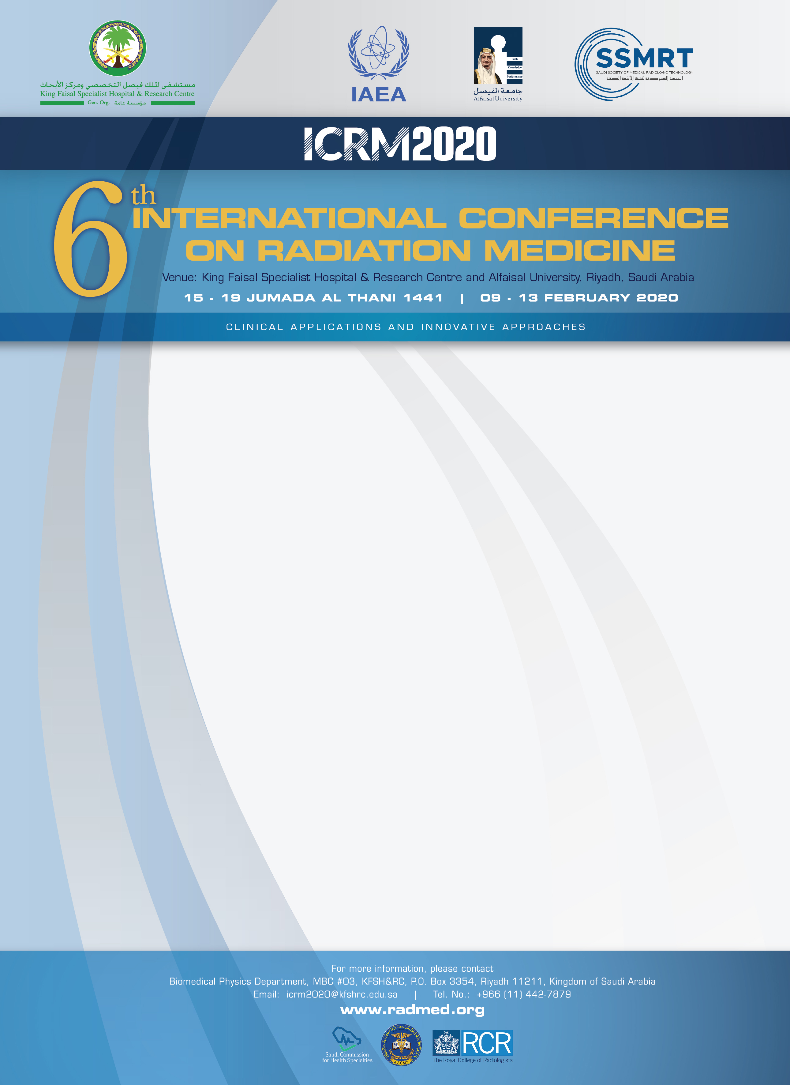

PARTICIPANT’S VISA BIODATA INFORMATION
NOTE: Please type or print all information as requested in the space provided below.
Name of Applicant (as in passport):
Passport #: |  | Place Issued:
Date Issued: |  | Expiry Date:
Name of Workplace: |  | Specialty or type of workplace activity:
Home Address: |  | Business Address:
Tel. No. (Home): |  | Tel. No. (Business)
Email Address: |  | Fax. No.
Date of Birth: |  | Gender: | Male Female
Place of Birth: |  | Marital Status: | Married Single
Nationality: |  | Religion:
Previous Nationality  (if any): |  | Profession/ Occupation
Nearest airport to Home: |  | Duration of stay in Saudi Arabia:
Country travelling from: |  | Nearest Saudi Embassy where visa is to be issued:
Signature: |  | Date:
IMPORTANT: To expedite visa processing, please send the following documentations with completed Visa Biodata Form:
- Copy of your passport photo page (full name, passport number, nationality, date of birth, place of issue and validity);
- Letter from current employer, verifying position/profession.
NOTE:
- Visa will be requested for Conference participants only.
- Applicant field of work should be in Radiation Medicine.
- Approval of visa application is not guaranteed.
- Issued visa will not be extended.
Send required information by email, fax or air mail to address provided below. This information must be received in our office no later than the submission deadline (21 January 2020) for adequate processing time.

Submit completed form to:

Biomedical Physics Department, MBC #03, King Faisal Specialist Hospital & Research Centre
P.O. Box 3354, Riyadh 11211, Kingdom of Saudi Arabia
Tel: +966 (11) 442-7879; Email: icrm2020@kfshrc.edu.sa; Website: www.radmed.org

